

[6CS005 - High Performance Computing](https://classroom.google.com/u/2/c/MTQ3NjkzNDMzMjUw)

Student ID: NP03A180161

Student Name: Sujan Pyakurel

Award/Course: BSc Hons Computer Science

Cohort/Batch: 4

Submission Date: October 16, 2020

Contents

01.cu 3

01b.cu 4

02.cu 5

03.cu 10

04.cu 13

05.cu 18

06.cu 20

factorise_3_4_block 31

factorise_3_Cuda 31

Makefile 32

# 01.cu

# 01cu.PNG

# 01b.cu

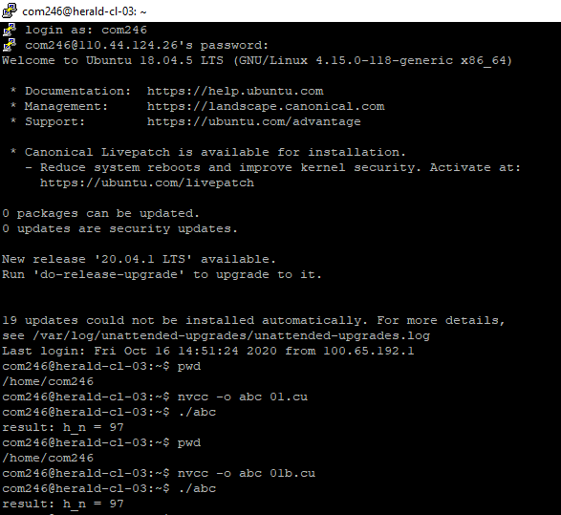

# 02.cu

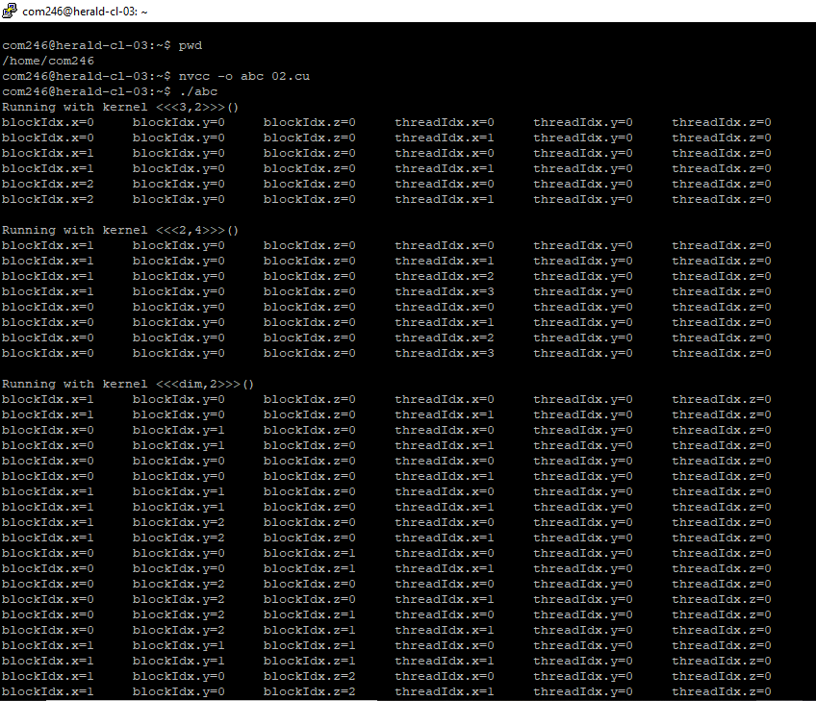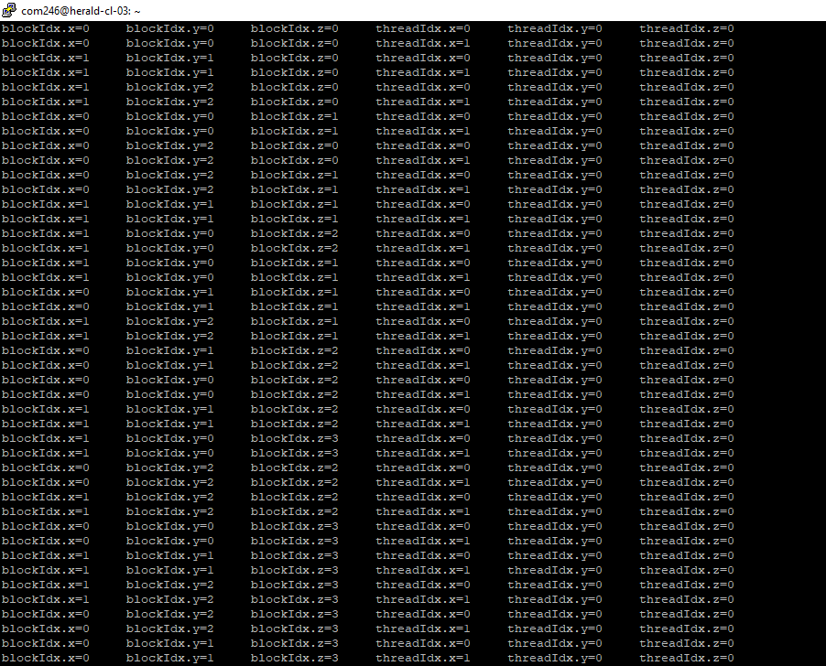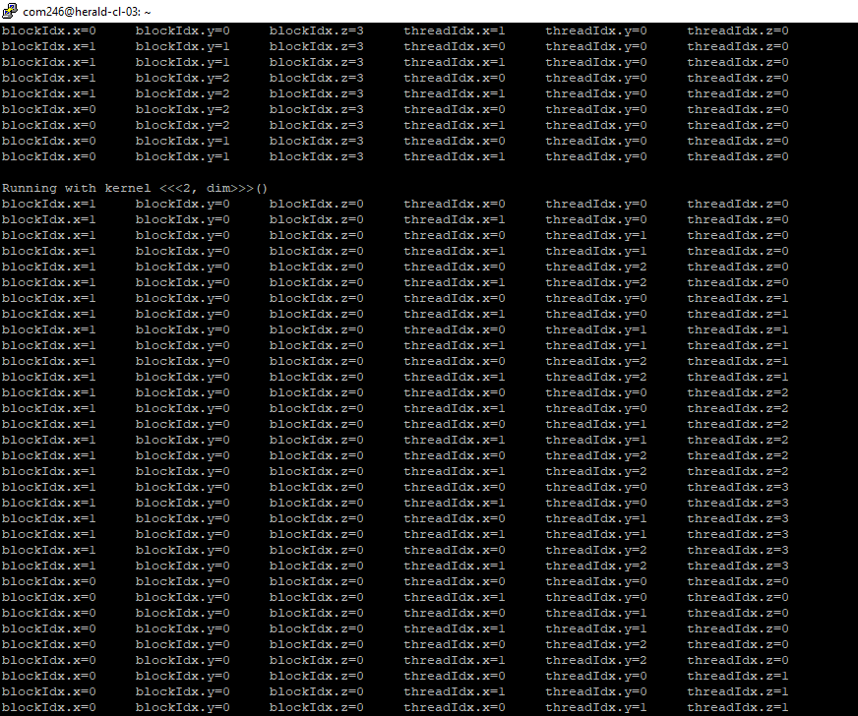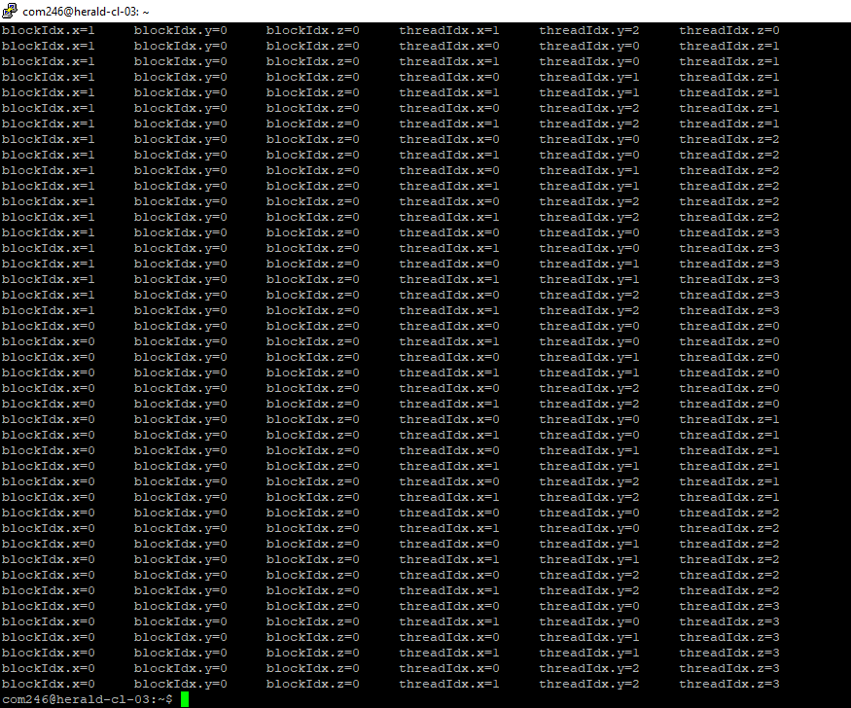

# 03.cu

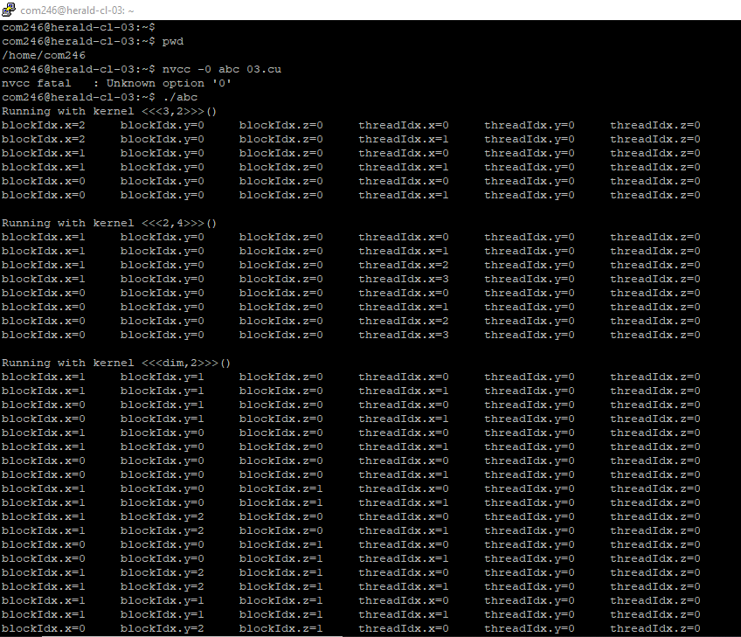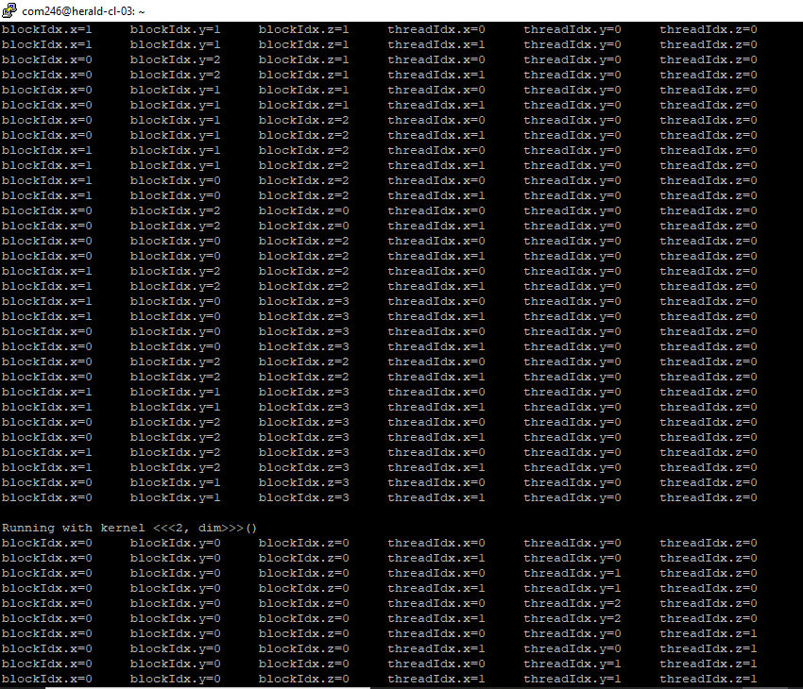

# 03cu3.PNG

# 04.cu

# 04cu1.PNG04cu2.PNG04cu3.PNG04cu4.PNG

# 05.cu

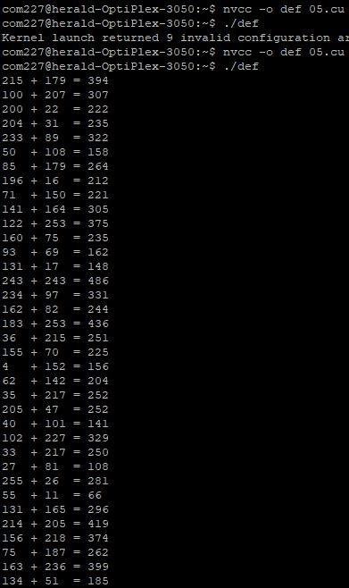

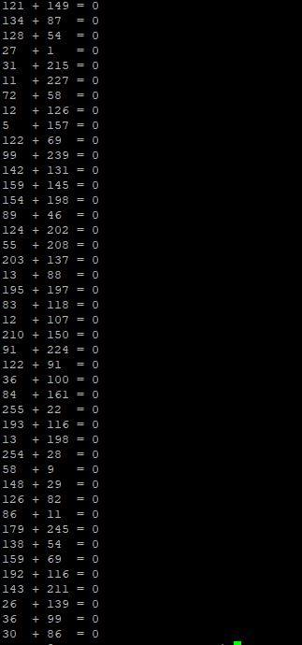

# 06.cu

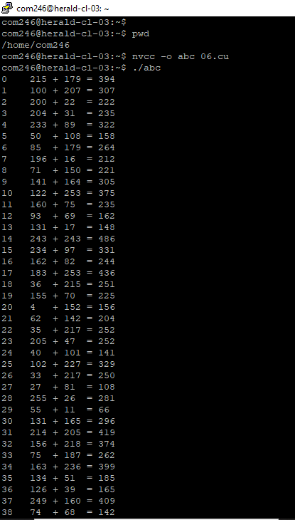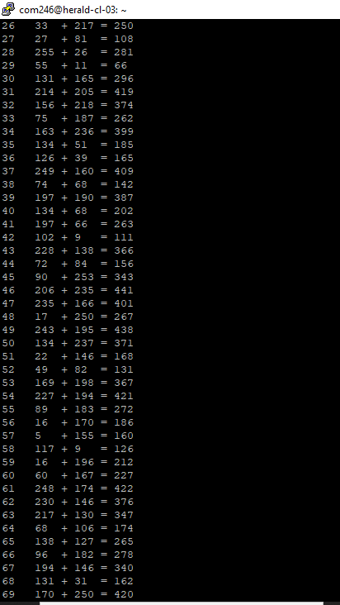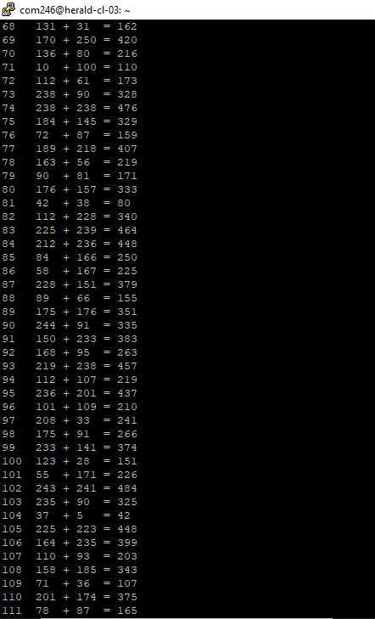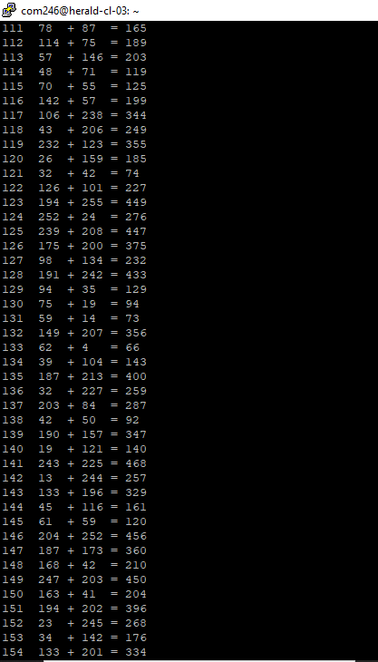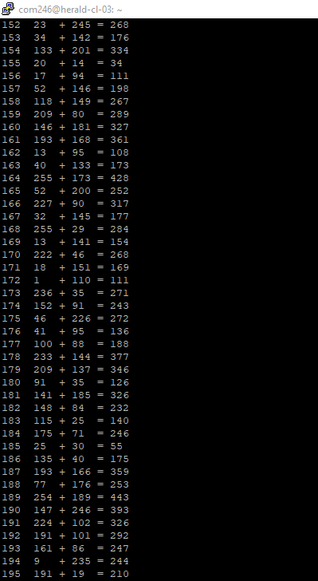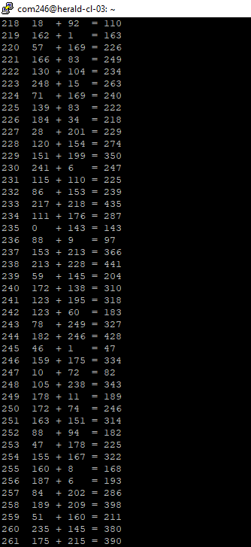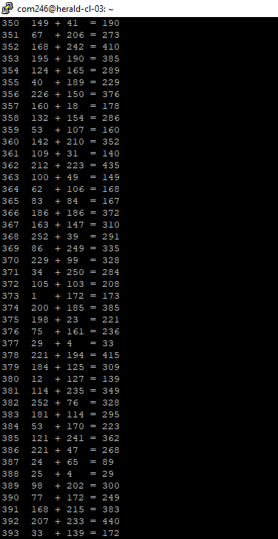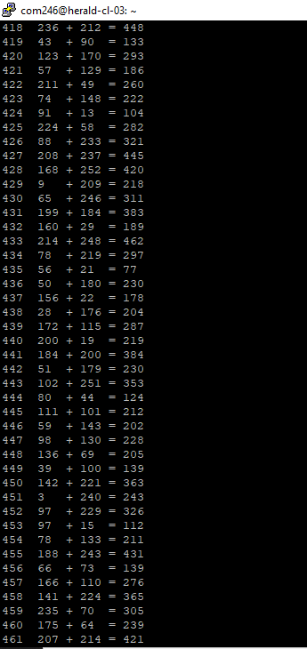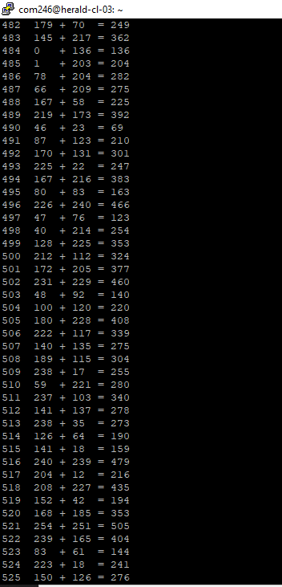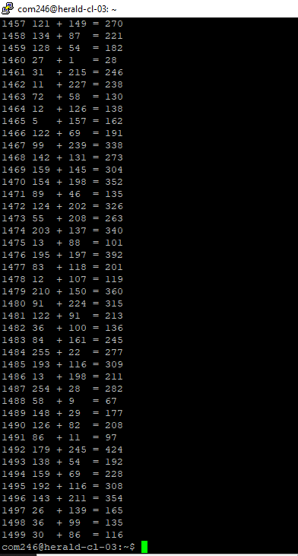

# factorise_3_4_block

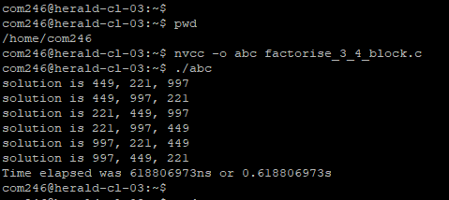

# factorise_3_Cuda

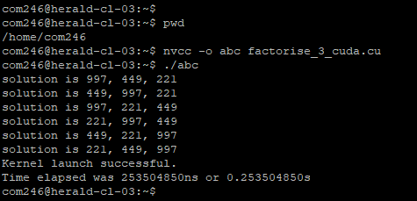

# Makefile

